Pre-Class Assignment

Jenkins: (Part 2)

This pre-class assignment will prepare you for the upcoming in-class assignment. There will also be a quiz about the readings and the set-up with a question asking if you did all the following.

# What to know.

* How to send a notification using Jenkins pipeline script?
* How does setting up a github webhook increase efficiency?
* How much ram does your AWS Jenkins server have?
* Where Jenkins runs tests.

# Understand what a CI/CD environment will look like and why it is important

6 min - <https://www.youtube.com/watch?v=LFDrDnKPOTg&t=1s>

* + **Stop at minute 6**

10 min - <https://www.dynatrace.com/news/blog/continuous-delivery-101-automated-deployments/>

# What will be accomplished in this assignment

In this assignment you will learn how to set Jenkins up to automatically deploy to a Docker image. In this pre-class assignment, you will learn the following:

1. How to install and setup docker on an AWS server
2. How to give Jenkins permission to use Docker
3. How to set Jenkins up to send email notifications
4. How to set up a Github webhook and connect it to Jenkins

# Start up your Jenkins AWS EC2 instance

1. Navigate to the AWS EC2 Dashboard
2. Right click your Jenkins Instance
3. Click Instance State -> Start

***Note:*** *There can be a cost associated with using EC2. AWS allows certain services to be run within a “free tier” for the first year of use of your AWS account, so most students can run an EC2 instance for free. However, if you have used up your free tier eligibility (by having created an AWS account more than a year ago, possibly for CS 260 or another class) you could be charged. However, the charges are small. If you create a EC2 t2.micro server for use in this lab, and leave it running for an entire week, you will be charged approximately $1.95 if you are not still eligible for the free tier. We recommend creating an EC2 t2.micro instance as you do this pre-class assignment and then stopping (but not terminating) your instance when you are done. You can then restart it when you need for the next two weeks when you do the two Jenkins tutorials for this class.*

# Set up Github Webhook

*In the last tutorial we polled Git for changes once a minute. This can be inefficient. By setting up a Webhook, Github will notify the Jenkins server when changes are made to the repository. This way Jenkins builds the project every time a change is made. However, everytime you stop and restart your AWS instance, the IP address changes.* ***If you stop the Jenkins instance and restart it, the EC2 IP address will probably change and you will need to update this webhook. There are AWS services that allow you to associate an unchanging domain name with an EC2 instance, but we don’t want to pay for those for this tutorial.***

1. **Navigate to the github repository for the last tutorial’s project**
2. Go to Settings
3. On the left side there is an option named Webhook. Click it
4. **Click add webhook**
   1. In the payload URL, paste [http://your_AWS_IP:8080/github-webhook/](https://github.com/jasonxris/JenkinsTutorialKey/settings/hooks/174310672)
   2. **Set content type to json**
   3. **Click add webhook**

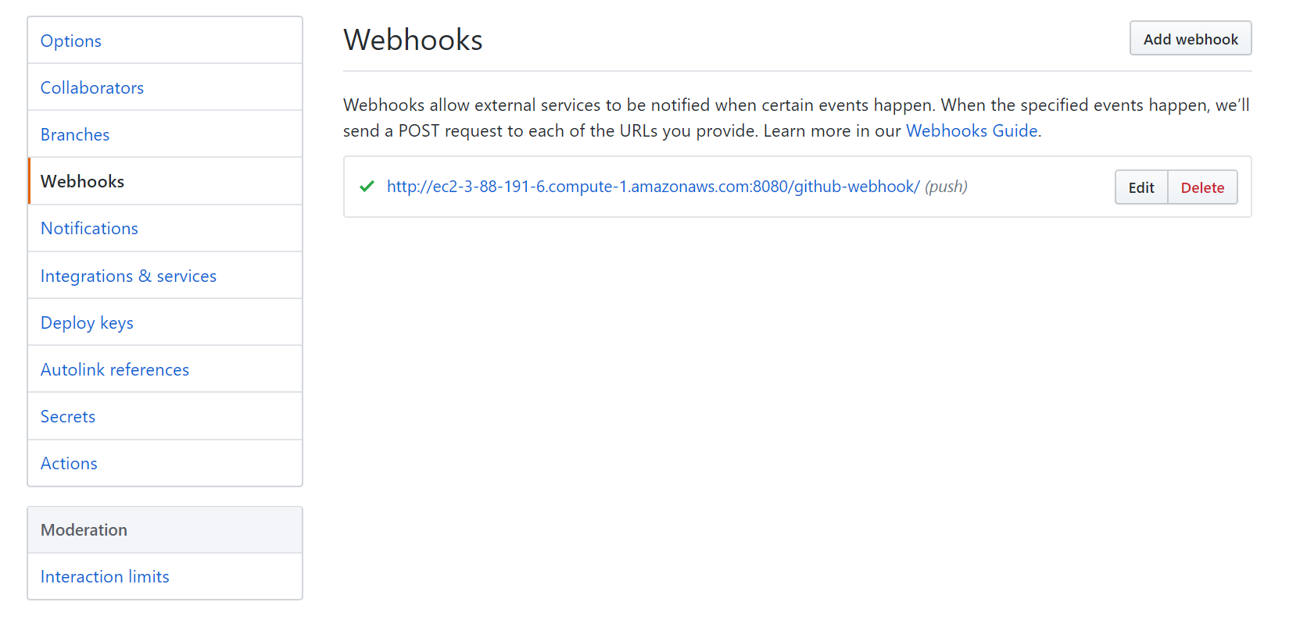

1. Go to your previous pipeline project -> configure -> click “**GitHub hook trigger for GITScm polling”**
2. Uncheck **Poll SCM**
3. Select Apply and Save
4. Jenkins should now trigger everytime you push file changes to your github repository
5. **Push your code** to makes sure your project automatically builds
   1. You may need to make a simple change in one of your project’s files to be able to push it
   2. Make sure you don’t have multiple pipelines that are using the same github repository. By default, Github seems to only send its push to one pipeline.

# Install/Setup Docker on AWS EC2

1. Install Docker
   1. **ssh into your AWS EC2 instance**
   2. In your AWS terminal install docker with the following command:
      1. sudo yum install -y docker
      2. Verify installation with : docker -v
2. Set permissions

*In order for Jenkins to use Docker, you need to grant Jenkins permission to use it*

* 1. In your AWS terminal add the correct permissions to allow your ec2 user and Jenkins program to use Docker with the following commands :
     1. sudo usermod -aG docker ec2-user
     2. sudo usermod -a -G docker jenkins
  2. Reboot the AWS device with the following command :
     1. sudo reboot
  3. After Rebooting AWS you will need to ssh back in to your server. You may need to restart Docker or Jenkins. Use the following commands to start those services:
     1. sudo service docker start
     2. sudo service jenkins start

1. Add docker credentials to Jenkins
   1. **Navigate to you Jenkins** dashboard : your_aws_ip:8080
   2. Sign in
   3. **Navigate to Manage Jenkins > Global Tools Configuration >Docker**
   4. Add docker
      1. Give it the name docker
      2. Check Install Automatically
      3. Add Installer > Download from docker.com
      4. Select latest version of docker

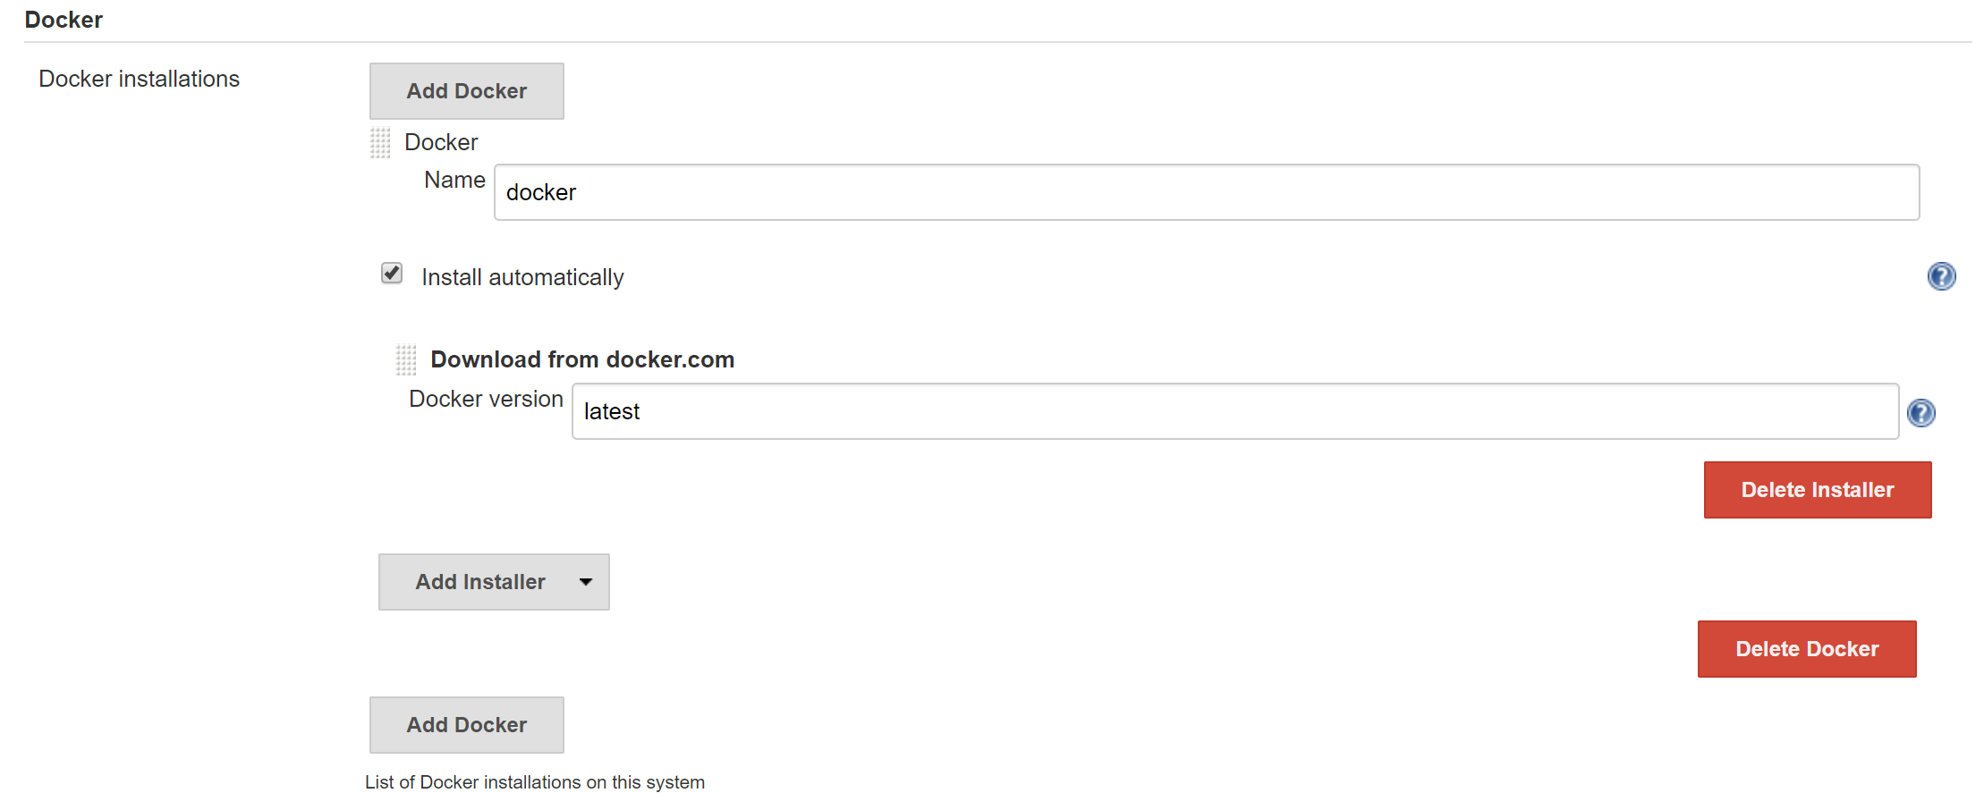

* 1. Apply, Save, and Navigate back to the Jenkins Dashboard
  2. Navigate to **Credentials > (Global) > Add Credentials** (start from Credentials in the left sidebar menu)
     1. Enter your username and password for DockerHub

**Note:** You should have a DockerHub account from a previous lab. If not, you will need to create one.

* + 1. Give it the ID and description : dockerhub
    2. The credentials screen should look like the screenshot below

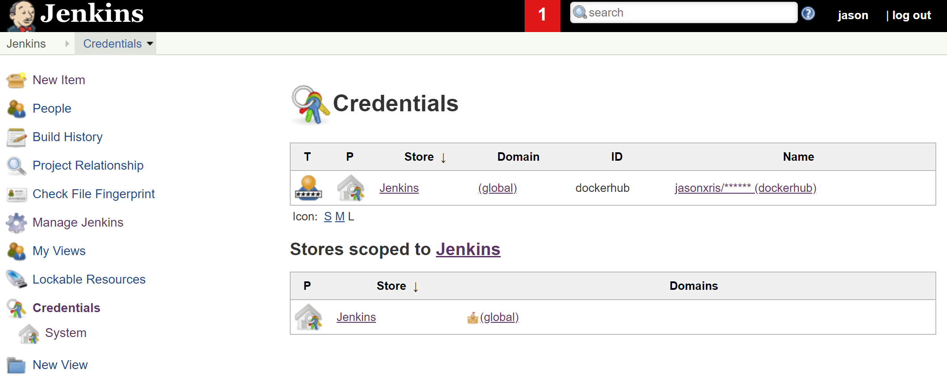

# Setup Jenkins to send a notification when a build fails

*Jenkins needs to be configured to use a specific email inorder to send notifications.***To make this step easier, make sure you have a gmail account.**

1. Navigate to Manage Jenkins> Configure System > E-mail Notification (at the bottom of the page)
   1. **DO NOT CONFIGURE EXTENDED EMAIL, WE WILL BE USING THE NORMAL E-mail Notification SERVICE**
   2. The SMTP server for gmail is : smtp.gmail.com
   3. Click “Advanced”
   4. **Check : Use SMTP authentication**
   5. Put your username and password information for your Gmail account
   6. **Check: Use SSL**
   7. **Set the SMTP port to the default : 465**
2. Set up Email Authentication

*For Jenkins to be able to use your email, it needs to authenticate itself. While some Email services may allow your app to sign in using just your username and password, Google has additional security.*

1. **Follow the tutorial below** inorder to **Set-Up the correct authentication** for your Jenkins server

<https://docs.google.com/document/d/1MUXXXsJlo2lLciRnBAX9dbKOLKFcmnrQaywi1j1kDMw/edit?usp=sharing>

1. Send a test e-mail to see if the e-mail notification settings were configured correctly.

*If everything was set up correctly, your settings should look like the screenshot below*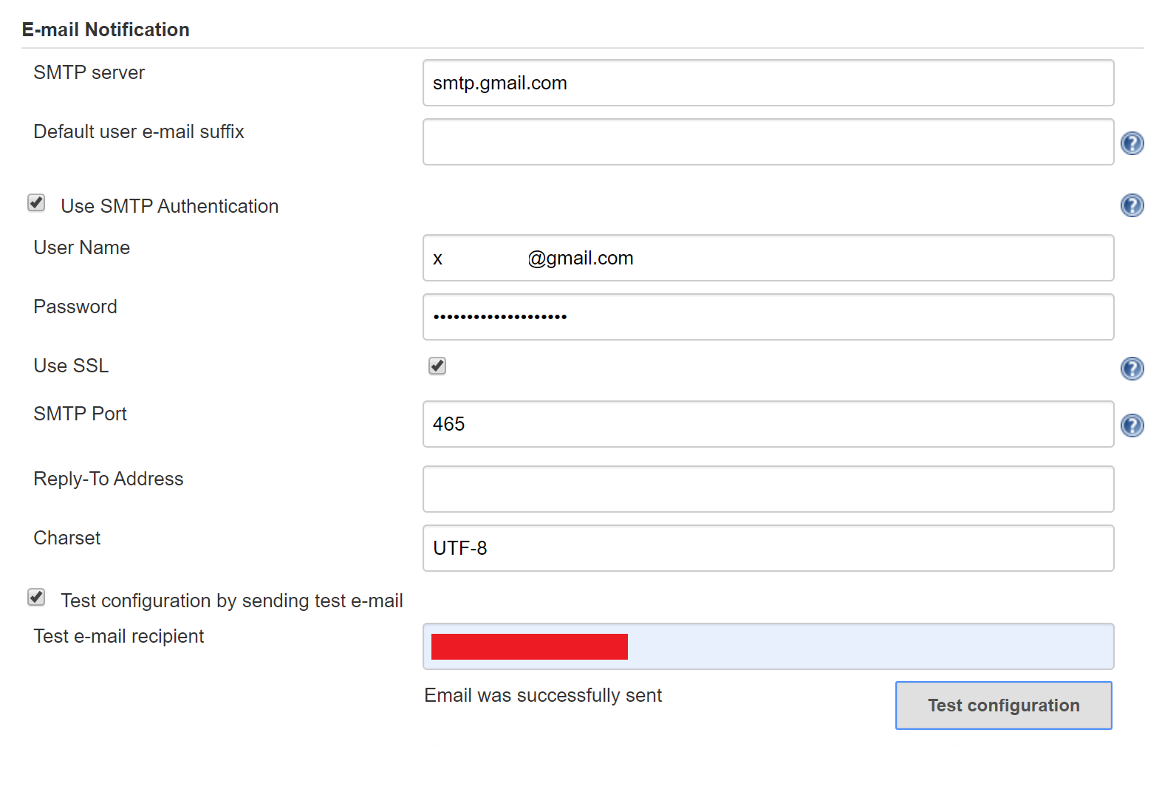

*If your test email works, then your email notification is set up and you are done with the Pre-class assignment*

# Stop Jenkins AWS EC2 instance

1. Stop Instance
   1. Navigate to the AWS EC2 Dashboard
   2. Right click your Jenkins Instance
   3. Click Instance State -> Stop
      1. **DO NOT CLICK TERMINATE**